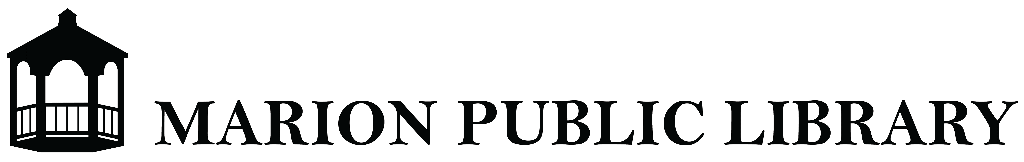

Local History Collection Policy
Local History resources are of lasting and cumulative value for developing local knowledge and understanding. Saving unique historical records, photographs, etc. that document the past is one of the important services of a public library.

Goals
The purpose of the Local History Collection is to serve the community through acquisition, classification, preservation and provision of access to a well-organized and balanced collection that documents Marion’s history.

Scope
The aim of the Local History Collection is to provide a range of materials reflecting the history of the community. Emphasis will be on the acquisitions of those materials which will contribute to the knowledge of the social, civic, religious, economic and cultural life, both past and present, of Marion, NY. Materials to be collected include books, diaries, yearbooks, pamphlets, newsletters, bulletins, periodicals, reports, letters, speeches, manuscripts, documents, maps, clippings, photographs, and genealogical records. The Collection may include a selection of materials about other local towns and materials about Wayne County, NY

Chronological Scope
Acquisitions from any time period may be considered

Geographical Scope
Collections will emphasize individuals, groups and organizations whose activities have principally been in Marion.

Materials for Inclusion
The following list provides guidelines for the type of material that may be sought for inclusion in the local history collection:
Published works:
- Published histories or other works (i.e. articles, dissertations, manuscripts, pamphlets or theses) relevant to Marion concerning buildings, businesses, history, organizations, and residents.
- Published works by Marion residents.
- Records of local businesses and associations, schools, churches, etc.
- Papers of prominent local families/individuals, genealogies and manuscripts.
- Relevant family history research papers and publications.
- Locally based publications such as newspapers, magazines, gazettes, newsletters, etc.
- Yearbooks from Marion Central School
Unpublished works:
- Archives of local organizations (archives must contain historically important information)
- Papers, correspondences, diaries, of Marion residents (must contain historically important information)
- Ephemera, including leaflets, flyers, pamphlets, original documents such as land deeds, certificates and military papers specifically concerning Marion.
- Documents/research papers/photographs relating to buildings (private, commercial and public) and property.
- Research papers pertaining to Marion.

- Other:
- Photographic works of local historical interest including prints, postcard, groups, buildings, landscapes, and events.
- Current and historic maps of Marion.
- Oral histories made about Watertown and its residents.

Approved by the Library Board of Trustees on August16, 2022

