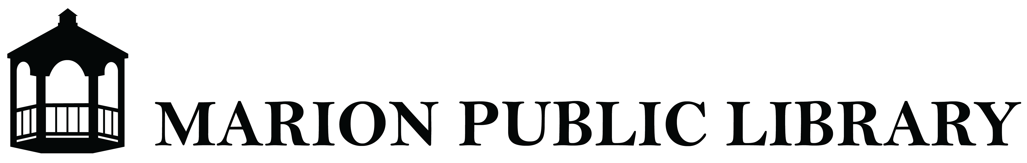

EMPLOYEE HEALTH SCREENING POLICY

Purpose

The Marion Public Library’s Board of Trustees is empowered to take the steps necessary to serve the community under its mission with the health and safety of the library staff and patrons as the top priority. Therefore, the Board of Trustees has adopted this Employee Health Screening Policy.

The primary goals of the Marion Public Library’s Employee Health Screen Policy are to:
- Comply with the criteria for reopening mandated in NY Forward (forward.ny.gov)
- Provide guidelines for a continuous health screening process for staff
- Reduce the risk of infection in, around, and on library facilities, materials, and equipment for library staff and patrons

The Manager, under the authority of the Board of Trustees, is designated to enforce this policy and the following processes to comply with current public health obligations and ensure a safe workplace.

Guidelines

- Mandatory, continuous health screening practices will be implemented for all staff
- Screening will be performed remotely and reported to the Director by Electronic Survey/Google Form before the staff member reports to the library
- Screening will include individual staff members:
  - Taking their own temperature and attesting that they do not have a fever.
  - Attesting they have not knowingly been in close or proximate contact in the past 14 days with anyone who has tested positive for COVID-19 or who has had symptoms of COVID-19
  - Attesting they themselves have not tested positive for COVID-19 in the past 14 days nor have they experienced any symptoms of COVID-19 in the past 14 days
- All staff screening responses collected on a daily basis will be reviewed by the Manager and a record of such review will be maintained
- If a staff member has a temperature of 100.3 or higher, they are not to report to work or they must leave the premises immediately, if already at work, and monitor symptoms
- If a staff member experiences the following symptoms, even if a fever is not present, they are not to report to work or the must leave the premises immediately, if already at work, and notify the Director:
  - Fatigue
  - Dry cough
  - Shortness of breath
  - Aches and pains
  - Sore throat
  - Nausea
  - Loss of smell or taste
- If a staff member tests positive for COVID-19 they must not report to work or they must leave the premises immediately, if already at work, and notify the Director
- The Director will notify the local department of health if a staff member tests positive for COVID-19 and follow guidance specific to workplaces with a positive case
- If a staff member has a fever or symptoms consistent with COVID-19 they must not report back to work until they have met all of the following criteria in consultation with a healthcare provider:
  - The staff member has had no fever for at least 72 hours (3 full days) without the use of medicine that reduces fevers
  - Respiratory symptoms have improved
  - They received two negative tests in a row at least 24 hours apart
- If a staff member tests positive for COVID-19 they must not report back to work until they have met all of the following criteria in consultation with a healthcare provider:
  - The staff member has had no fever for at least 72 hours (3 full days) without the use medicine that reduces fevers
  - Respiratory symptoms have improved
  - At least 10 days have passed since their symptoms first appeared
- The Manager will keep the health status of staff members confidential

Staff members who cannot medically comply with this policy must discuss options for reasonable accommodation(s) with the Manager.

Reporting to work with a fever or symptoms consistent with COVID-19 or failure to adhere to the guidelines outlined above will be considered a violation of library policy and may result in disciplinary action.

Compensation

The library will adhere to the Families First Coronavirus Response Act (FFCRA) regarding paid sick leave or expanded family and medical leave for specified reasons related to COVID-19. More information regarding FFCRA can be found on the U.S. Department of Labor website.

Authority & Evaluation

This policy and related procedures will be enforced under all current and future New York State Executive Orders and the criteria mandated for organizations to safely and legally reopen and operate under NY Forward. The practices in this policy may be updated as needed to conform with modifications to NY Forward, as well as mandates from the Center for Disease Control (CDC), Occupational Safety and Health Administration (OSHA), and local government agencies.

Questions or concerns regarding this policy should be brought to the library Manager.

This policy will remain in effect until the Board of Trustees votes to remove or revise it.

ADOPTED by the Marion Public Library Board of Trustees 6/16/2020

